Business Requirements Document(BRD) Template
Project/Initiative
Month 20YY
Version X.XX

Company Information

Document Revisions
Date | Version Number | Document Changes
17/06/2026 | 0.1 | Initial Draft

Approvals
Role | Name | Title | Signature | Date
Project Sponsor
Business Owner
Project Manager
System Architect
Development Lead
Marketing Manager
User Experience (UX) Lead
Data Analytics Lead

Introduction

Project Summary

Objectives
The objective of the Hotel Search and Filtering Module is to enable users to quickly find and compare available hotels based on their travel criteria while increasing the search-to-booking conversion rate by at least 15% within 6 months after deployment.

Background
The company operates an online hotel booking platform where users search for accommodations based on destination, travel dates, and guest information.

Business Drivers
- Increase revenue through higher booking conversion rates.
- Promote strategic partner hotels and higher-margin properties.
- Improve customer satisfaction through accurate real-time availability.
- Reduce booking abandonment caused by outdated inventory information.
- Expand hotel inventory based on user demand analytics.
- Support international market growth through localization and currency support.
- Improve competitiveness against major hotel booking platforms.

Project Scope
The project covers the search and hotel discovery process from entering search criteria until selecting a hotel from the search results.
The solution includes:
- Search criteria entry.
- Search result generation.
- Filtering and sorting.
- Hotel result presentation.
- Real-time inventory synchronization.
- Search analytics collection.
- Map-based hotel visualization.

In Scope Functionality
- Destination search with autocomplete.
- Date selection.
- Guest configuration (adults and children with age).
- Hotel search execution.
- Hotel result listing.
- Filtering and sorting.
- Recommended hotel prioritization.
- Marketing tag display.
- Real-time availability updates.
- Map view.
- Multi-language support.
- Multi-currency support.
- Search analytics collection.

Out of Scope Functionality
- Any functionality beyond hotel selection from the search results, including the booking and checkout process.
- Reporting and analytics beyond search-related analytics collection.
- Any functionality, feature, integration, or deliverable not explicitly described in the Project Scope section of this document

System Perspective
[Provide a complete description of the factors that could prevent successful implementation or accelerate the projects, particularly factors related to legal and regulatory compliance, existing technical or operational limitations in the environment, and budget/resource constraints.]

Assumptions

Constraints
- Dependence on external API availability.
- Project budget limitations.
- Development timeline restrictions.
- Existing platform architecture constraints.
- Third-party synchronization frequency limitations.
- Regulatory requirements regarding user data processing.

Risks

Issues

Business Process Overview
[Describe how the current process(es) work, including the interactions between systems and various business units. Include visual process flow diagrams to further illustrate the processes the new product will replace or enhance.
Use case documentation and accompanying activity or process flow diagrams can be used to create the description(s) of the proposed or “To-Be” processes.]

Current Business Process (As-Is)
At any point during or after deployment of web apps or web sites (internal or external) to support business activities, development/support teams may create and deploy widgets.
- CMS / database administrators for the employee portal use the CMS tool to create widgets. They can test widgets in the designated staging environment, then register them and deploy to production.
- Development teams may deploy widgets to development and testing environments set up for their development projects. They must check widget code into and out of the source code repository according to their projects’ development schedule.
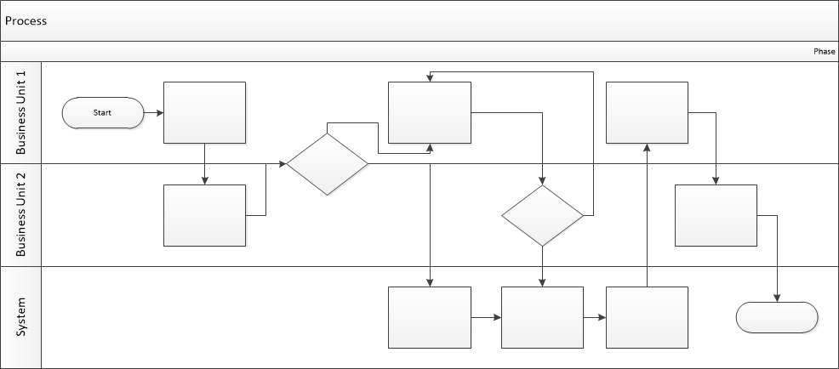

Proposed Business Process (To-Be)
- Technical Lead searches repository
- If widget is not found, user creates a new widget name record.
- WINS validates that all fields have been completed.
- WINS confirms that no similar widgets exist
- User confirms record to be created.

- User searches repository to locate existing widget description.
- WINS displays record
- User selects Edit to open and modify record
- WINS validates all fields completed correctly
- User confirms changes.
- WINS confirms changes and updates Audit table.


Stakeholder Requirements
[The specific user requirements elicited from stakeholders should be listed, categorized by both priority and area of functionality to smooth the process of reading and tracking them. Include links to use case documentation, and other key reference material as needed to make the requirements as complete and understandable as possible. You may wish to incorporate the functional and non-functional requirements into a traceability matrix that can be followed throughout the project.]
SR-001
The search module shall be designed to maximize the conversion rate from search results to completed bookings.
SR-002
The system shall support the prioritization and promotion of selected accommodation offers within search results based on predefined business rules, including profitability, commission rates, strategic partnerships, or promotional campaigns
SR-003
The system shall ensure that hotel availability and booking status are synchronized with external providers in near real time.
SR-004
The system shall capture and store user search behavior data, including applied filters, search parameters, and cases where searches return no results.
SR-005
The user shall be able to sort search results by criteria such as recommended hotels, price, guest rating, and distance from the destination.
SR-006
The user shall receive search results within 2 seconds under normal operating conditions.
SR-007
The user shall be able to use the search interface in multiple supported languages and currencies.
SR-008
The user shall be able to refine search results using filters, including price range, guest review score, free cancellation, and available amenities (e.g., Wi-Fi, parking, breakfast).

The requirements in this document are prioritized as follows:
Value | Rating | Description
1 | Critical | This requirement is critical to the success of the project. The project will not be possible without this requirement.
2 | High | This requirement is high priority, but the project can be implemented at a bare minimum without this requirement.
3 | Medium | This requirement is somewhat important, as it provides some value but the project can proceed without it.
4 | Low | This is a low priority requirement, or a “nice to have” feature, if time and cost allow it.
5 | Future | This requirement is out of scope for this project, and has been included here for a possible future release.

Functional Requirements
Req# | Priority | Description | Rationale | Use Case Reference | Impacted Stakeholders
General / Base Functionality
FR-G-001 | 1 | The system shall allow users to search for destinations using an intelligent autocomplete input field. | Reduces user effort and improves search accuracy. |  | End User  Business Owner
FR-G-002 | 1 | The system shall allow users to specify:  - Destination city  - Check-in date  - Check-out date  - Number of adults  - Number of children  - Age of each child | Pricing and availability depend on guest composition. |  | End User  Business Owner
FR-G-003 |  | The system shall support business rules that prioritize recommended hotels based on profitability, commissions, partnerships, or promotional campaigns. | Supports revenue optimization objectives. |  | Business Owner, Marketing Team
FR-G-004 | 1 | The system shall provide filters for:  - Price per stay  - Review score  - Free cancellation  - Wi-Fi  - Parking  - Breakfast | Allows users to quickly identify suitable accommodations. |  | End Users, Business Owner
FR-G-005 | 1 | The system shall display hotel cards containing:  - Hotel name  - Main room image  - Total price for stay  - Review score  - Distance to city center  - Availability status | Provides sufficient information for decision making |  | End Users
FR-G-006 | 2 | The system shall display marketing tags on hotel search results based on predefined business rules to highlight promotional or high-priority offers. | Helps users quickly identify attractive or time-sensitive offers, improves the visibility of promoted accommodations, and encourages faster booking decisions |  | End User  Business Owner
Security Requirements
FR-S-001 | 1 | The system shall restrict access to search analytics data and business configuration (e.g., hotel prioritization rules and marketing tag rules) to authorized administrative users only. | Prevents unauthorized access or modification of sensitive business information. |  | Business Owner, End Users
Reporting Requirements
FR-R-001 | 2 | The system shall generate reports showing:  - Most used filters  - Searches with no results  - Most searched destinations  - Search-to-booking conversion rates  The system shall make these reports available through an administrative reporting dashboard and support on-demand export in CSV and PDF formats. Additionally, the system shall support automated delivery of the reports via email to authorized stakeholders on a configurable schedule (e.g., daily, weekly, or monthly) | Supports business growth and inventory planning. |  | Business Owner
Usability Requirements
FR-U-001 | 1 | The system shall provide hotel search results in both list and map views and allow users to switch between these views. | Improve the hotel search experience by enabling users to view results in their preferred format. |  | End Users
Audit Requirements
FR-A-001 | 1 | The system shall maintain audit logs of:  - Search requests  - Filter selections  - Result ranking decisions  - Inventory update events | Supports troubleshooting, compliance, and analytics validation. |  | Business Owner

Non-Functional Requirements
[Include technical and operational requirements that are not specific to a function. This typically includes requirements such as processing time, concurrent users, availability, etc.]
ID | Requirement
NFR-001 | The system shall return search results within 2 seconds for 95% of search requests
NFR-002 | Availability status changes received from external providers shall be reflected in the search results within 5 seconds.
NFR-003 | The search module shall maintain 99.9% monthly uptime excluding planned maintenance.
NFR-004 | The system shall support a minimum of 10,000 concurrent users without degradation of response times beyond defined performance thresholds.
NFR-005 | The system shall support multiple languages and currencies, allowing new languages and currencies to be added without requiring code changes to core search functionality.

Appendices

List of Acronyms
[If needed, create a list of acronyms used throughout the BRD document to aid in comprehension.]

Glossary of Terms
[If needed, identify and define any terms that may be unfamiliar to readers, including terms that are unique to the organization, the technology to be employed, or the standards in use.]

Related Documents
[Provide a list of documents or web pages, including links, which are referenced in the BRD.]

